LAB 6
Question 1: Write a code to perform bit stuffing and byte stuffing.
Answer:
Bit Stuffing using C language:-
#include<stdio.h>
#include<string.h>
int main()
{
int a[20],b[30],i,j,k,count,n;
printf("Enter frame size (Example: 8):");
scanf("%d",&n);
printf("Enter the frame in the form of 0 and 1 :");
for(i=0; i<n; i++)
scanf("%d",&a[i]);
i=0;
count=1;
j=0;
while(i<n)
{
if(a[i]==1)
{
b[j]=a[i];
for(k=i+1; a[k]==1 && k<n && count<5; k++)
{
j++;
b[j]=a[k];
count++;
if(count==5)
{
j++;
b[j]=0;
}
i=k;
}
}
else
{
b[j]=a[i];
}
i++;
j++;
}
printf("After Bit Stuffing :");
for(i=0; i<j; i++)
printf("%d",b[i]);
return 0;
}

Output -
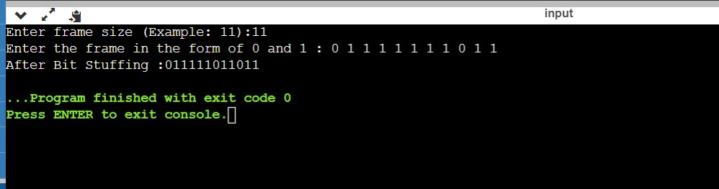

Byte Stuffing using C language:-
Answer-
#include<stdio.h>
#include<string.h>
void main(){
char frame[50][50],str[50][50];
char flag[10];
strcpy(flag,"flag");
char esc[10];
strcpy(esc,"esc");
int i,j,k=0,n;
strcpy(frame[k++],"flag");
printf("Enter no.of String :\t");
scanf("%d",&n);
printf("Enter String \n");
for(i=0;i<=n;i++)
{
gets(str[i]);
}
printf("You entered :\n");
for(i=0;i<=n;i++)
{
puts(str[i]);
}
printf("\n");
for(i=1;i<=n;i++)
{
if(strcmp(str[i],flag)!=0 && strcmp(str[i],esc)!=0)
{
strcpy(frame[k++],str[i]);
}
else
{
strcpy(frame[k++],"esc");
strcpy(frame[k++],str[i]);
}
}
strcpy(frame[k++],"flag");
//frame[k++]='\0';
printf("------------------------------\n");
printf("Byte stuffing at sender side:\n\n");
printf("------------------------------\n");
for(i=0;i<k;i++)
{
printf("%s\t",frame[i]);
}
}

Output -
